**Database Modification Problem 4**

4) Change the location name of “Door” to “Gate” for the row inserted in modification problem 2.

A) ***Syntax of Update Statement :***

UPDATE TABLE_NAME

SET COL1 = VAL1, COL2=VAL2,…

WHERE CONDITION;

***Example :***

**UPDATE** Location

**SET** LocName=’Gate’

**WHERE** LocNo=’L107’

**AND** FacNo=’F104’;

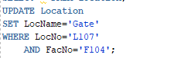

***Output :***

**Before Updating After Updating**

